## FR1: load patients from file

Design Pattern: Adapter Pattern

The System is required to take data from the text file. The PatientFileLoader class is already given to me to read the patient data from a local file (patients.txt in this case). However, it is not compatible with the interface expected from the class (AbstractPatientDatabaseLoader), since it was designed for the database. Adapter pattern is used to solve this problem; it allows incompatible interfaces to work together by creating a class which convert one interfaces into another. In this case, the adapter is (FilePatientDatabaseLoader), it adapts the PatientFileLoader to conform to AbstractPatientDatabaseLoader interface.

**How it works:**

1. Creates an adapter that implements AbstractPatientDatabaseLoader

2. Uses the existing PatientFileLoader internally

3. Converts between the database-style interface and file loading

4. Allows easy switching between database and file loading with one line change

5. Maintains the existing PatientFileLoader implementation

**Git Commits:**

* **I first implemented the PatientFileLoader in commit f52438.**
* **I created the adapter PatientFileLoaderAdapter in commit 42df08.**
* **The adapter was implemented in 4f473**
* **Other related commits:**

## FR2: load patients from file and database

Design Pattern: Composite Pattern

The Composite pattern is used to implement this function requirement. The system is required to load patients from three ways: from database, from text file and from both. And is required to switch among these configurations easily with a line of code change. Composite is ideal for dealing this case because it can help treat different loaders (PatientDatabaseLoader and PatientFileLoader) and the combination (CompositePatientLoader) evenly through a common interface which is AbstractPatientDatabaseLoader. This enables us to create a tree-like structure where the composite can contain individual loaders or other composites, executing them in a specific order while hiding the complexity of managing multiple data sources.

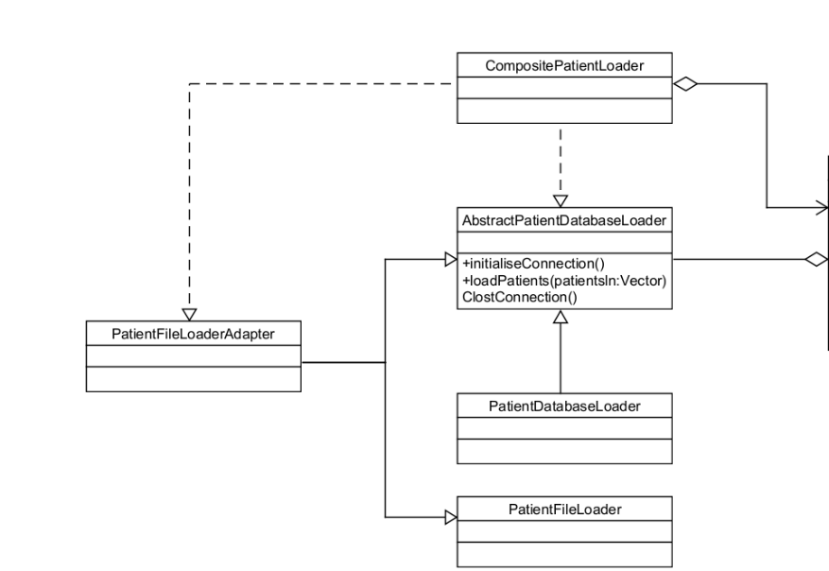

**How it works:**

1.Creates a CompositePatientLoader that implements AbstractPatientDatabaseLoader

2. Allows multiple loaders to be added to a single composite loader

3. Maintains order of execution (database first, then file) by order of addition

4. Delegates all operations (initialize, load, close) to contained loaders in sequence

5. Uses existing PatientDatabaseLoader and PatientFileLoaderAdapter implementations

6. Allows switching between configurations by adding/removing loaders:

- Database only: Add just PatientDatabaseLoader

- File only: Add just PatientFileLoaderAdapter

- Both (default): Add both loaders in order

7. Provides single-line configuration changes through the addLoader method

8. Maintains the existing database and file loader implementations unchanged

**Git Commits:**

* **I created the composite PatientFileLoader in commit 53fb4e.**
* **The adapter was implemented in 486abb.**
* **Other related commits:**

3. Strategy Pattern

4. Observer Pattern